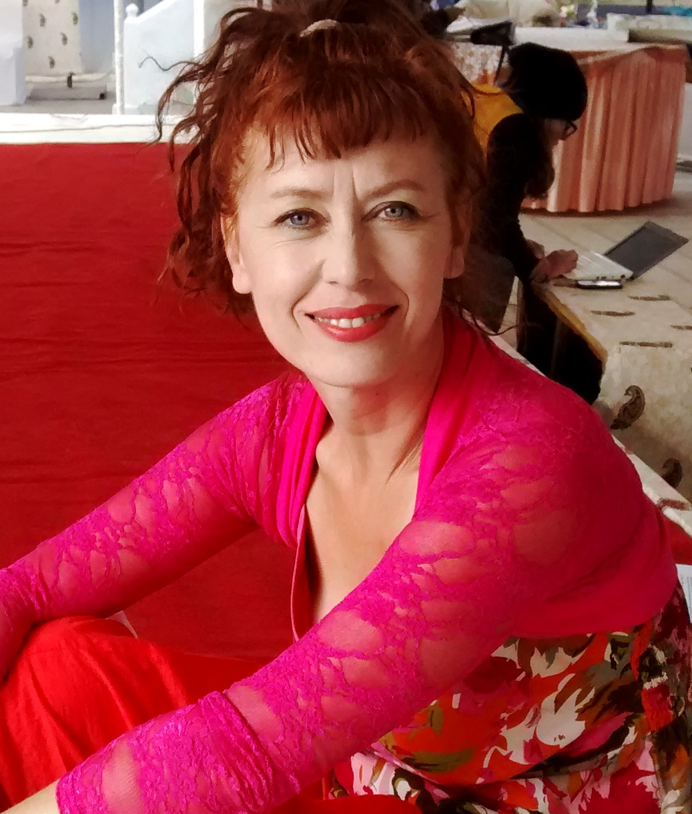 ‘Cat is one of our great storytellers’ Michael Morpurgo

Dear Parents & Guardians

The globetrotting storyteller and author CAT WEATHERILL will be visiting our school on TUESDAY 17 MARCH. We are excited already ☺

Cat finds that after her story sessions, many children are keen to read the books to find out what happens next. She will therefore be bringing books with her for any children who would like to buy a copy of their own.

Cat has written four books: Wild Magic (age 9+/ £7) Barkbelly (8+/£7) Snowbone (8+/£6) and Jaco the Leek (6+/£5) She also has a story CD – Big Happy Stories – for ages 4+ (£5)

Every book or CD will be signed by Cat and dedicated to the child.
Please be assured, there is absolutely no obligation to buy!



